Time Series Analysis
Task 1
Kiara Angelys Gänger
Western Governor University
D213 | Advanced Data Analytics

Scenario 2 Task 1 Telecommunications Time Series (Churn)
As part of the "churn” project, executives would like to see consider a time series on revenue from the first years of operation. Once they understand any patterns in that data, they feel confident in understanding the impact of churn in current times.

Part I: Research Question

Purpose of Report

Question
How can daily revenue trends from the last two years help forecast future revenue and give insights into customer churn for better retention strategies?

Goal
My goal is to build a predictive model using time series analysis to forecast future revenue, that can provide insight that will help guide our company with coming up with strategies for customer retention.

Part II: Method Justification

Assumptions of a Time Series Model
Stationarity Data: A key assumption in time series modeling is that the data is stationary. This means that the statistical properties like mean, variance, and autocovariance of the time series do not change over time. This allows for a more reliable forecasting because it assumes the patterns remain consistent over time. If the data is non-stationary, data transformations are often done to make it stationary.
Autocorrelated data: Another key assumption in time series modeling is that the data may show autocorrelation. Autocorrelation is when values in the series are correlated with previous values. This is important to model because it shows the relationship between a time point and previous time points, helping to capture dependencies that can improve forecast accuracy. Time series models like ARIMA incorporate this autocorrelation into the forecasting process.

Part III: Data Preparation

Data Cleaning Process

Line Graph
This line graph is visualizing the realization of the time series. It represents the last two years including a leap year totaling 731 days. The send variable is Revenue which represents the amount in millions of dollars. The plot below shows an upward trend in revenue in the last 2 years (Elleh, 2024).

Describe the Time Step Formatting
The time step in this dataset is daily, and the length of this series is 731 days (Elleh, 2024). Looking at the results, I can confirm that there are no gaps, NA’s, null or duplicates in the data. Which lets me know that the data is clean and complete.
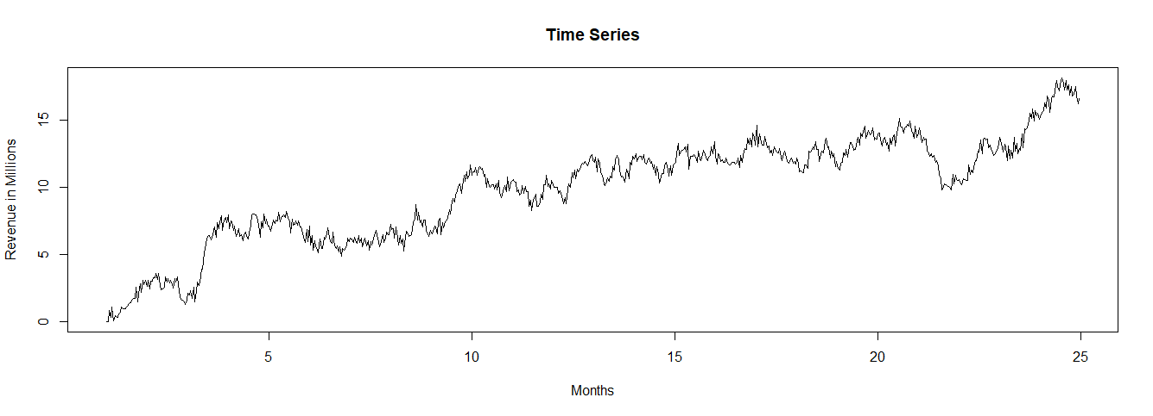

Stationarity Evaluation
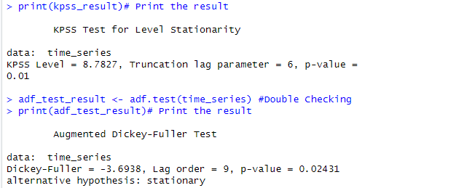
To evaluate the stationarity of the time series, I first performed the Kwiatkowski-Phillips-Schmidt-Shin (KPSS) test. This returned a KPSS Statistic result of 8.7827, and a p-value of 0.01. it indicates that the time series is non- stationary and may contain a unit root. As a precautionary measure I ran the Augmented Dickey-Fuller test to confirm my findings. In the ADF test, I got an ADF statistic of -3.6938 and a p-value of 0.02431. This test indicates that the time series is stationary unlike the KPSS test.
Since the results are conflicting, I apply a first order of differencing and then run both the KPSS and the ADF again. This time both tests came back with matching stationary results, concluding that the first order of differencing worked.
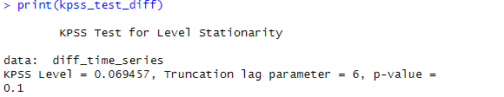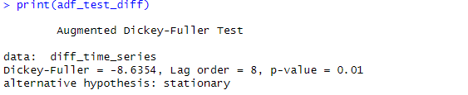
The plot below is a visual of the time series stationary status.
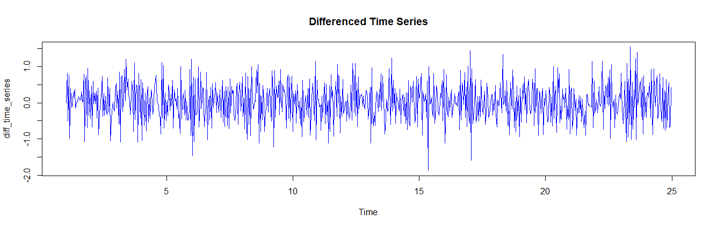

Steps Used to Prepare the Data
The steps I took to prepare the data are:
- Load the dataset using the read.csv command in R
- Created a chart using the plot() command to visualize the data and check for any null values
- Test Time Series to determine if the time series was stationary using both the ADF and KPSS test
- I split the data into training and test sets using the 70/30 rule Training/Test.
  - Testing consists of 218 days and training as 512 days

Code Used: (Elleh, 2024), (Bobbitt, 2020), (R CODER , 2024)
# Load necessary libraries
library(tseries)
library(tidyverse) # For base packages and charts
library(forecast)
library(lubridate) # For date manipulation
library(xts) # For time series objects with date index

# Load the dataset
df <- read.csv(
"C:/Users/kiara/OneDrive/WGU MSDA/D213 Advanced Data Analytics/Task 1/teleco_time_series.csv"
)
View(df)

# C1. Line Graph Visualizing
tele_revenue <- df$Revenue
day <- df$Day
tele_trend <- lm(tele_revenue ~ day)
plot(
tele_revenue,
xlab = "Time in Days",
ylab = "($Millions) Revenue",
type = "l",
main = "Time Plot: Telecom Revenue Per Day)"
)
abline(tele_trend, col = "red", type = "2")
legend(x = "topright",
legend = c("Revenue", "Trend"),
lty = c(1, 2), # Line types
col = c(1, 2), # Line colors
lwd = 2)

#C2. Time Step Formatting
is.data.frame(df)
df_vector <- df[['Revenue']]
is.vector(df_vector)
glimpse(df)
any(is.na(df)) # Check for NA values in data set
is.null(df) # Check for null values in data set
anyDuplicated(df$Day) # Check for duplicates in Day
time_series <- ts(df_vector, frequency = 731 / 24) # Convert to time series
is.ts(time_series) # Verify time series object
plot(time_series,
main = "Time Series",
ylab =
"Revenue in Millions",
xlab = "Months") # Plot time series

# C3. Evaluate the stationarity of the time series
kpss_result <- kpss.test(time_series)
print(kpss_result)# Print the result
adf_test_result <- adf.test(time_series) #Double Checking
print(adf_test_result)# Print the result

# Apply first-order differencing to the time series
diff_time_series <- diff(time_series, differences = 1)
# Remove NA values introduced by differencing
diff_time_series <- na.omit(diff_time_series)
# Plot the differenced time series to visually check stationarity
plot(diff_time_series, main = "Differenced Time Series", col = "blue")
# Run ADF test on the differenced series
adf_test_diff <- adf.test(diff_time_series)
print(adf_test_diff)
# Run KPSS test on the differenced series
kpss_test_diff <- kpss.test(diff_time_series)
print(kpss_test_diff)

# C4 Data Spliting
set.seed(1)
#Use 70% of dataset as training set and remaining 30% as testing set
sample <- sample(
c(TRUE, FALSE),
length(diff_time_series),
replace = TRUE,
prob = c(0.7, 0.3)
)
train <- diff_time_series[sample]
test <- diff_time_series[!sample]
#view dimensions of training and testing set
length(train)
length(test)

## write.csv( diff_time_series, "C:\\Users\\kiara\\OneDrive\\WGU MSDA\\D213 Advanced Data Analytics\\Clean Time Series.CSV")
## write.csv( train, "C:\\Users\\kiara\\OneDrive\\WGU MSDA\\D213 Advanced Data Analytics\\Clean Time Series training.CSV")
## write.csv(test,"C:\\Users\\kiara\\OneDrive\\WGU MSDA\\D213 Advanced Data Analytics\\Clean Time Series testing.CSV")

Part IV: Model Identification and Analysis

Analyze the Time Series

The Annotated Findings:

Seasonality - cycles that repeat regularly over time (Elleh, 2024)
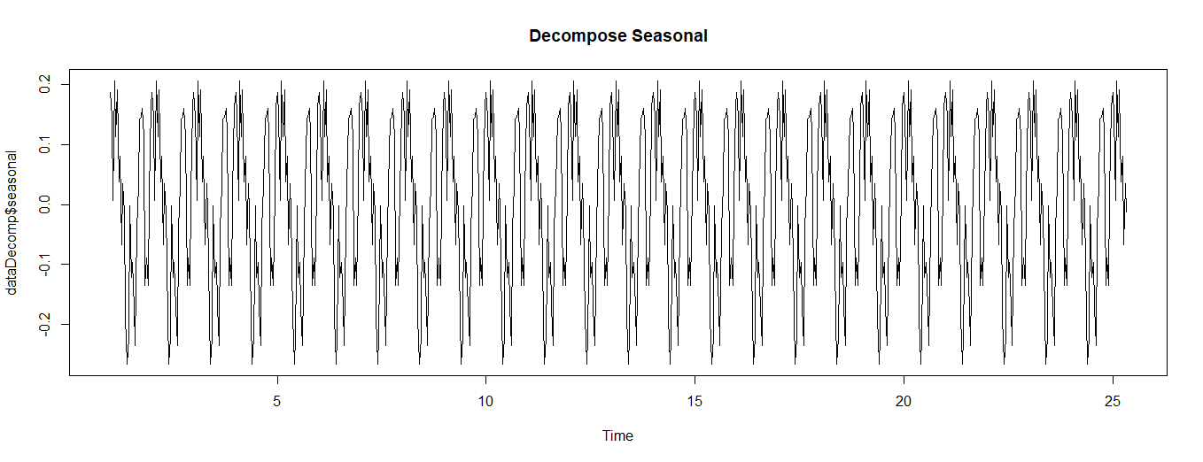I view this part of the task, I created two plots. The first one gives me an overview of the seasonal fluctuations over the two years, showing me a repeating cycle every month. This suggests a seasonal component, but since it is such a long-time frame it is difficult to determine when the spikes happen.
  - Trends - The upward or downward overall direction of the series over a period (Elleh, 2024)
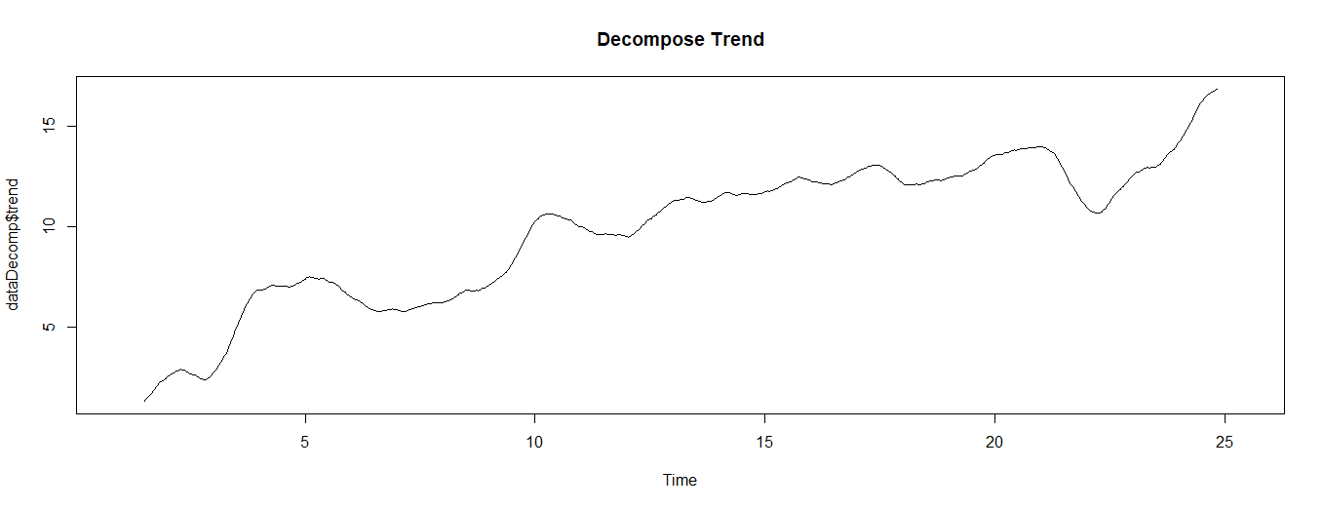
The graph above shows a long-term upward trend pointing to a growth in customer engagement and revenue. There are times when it dips, which taking a closer look could help the company understand churn rates.
  - Auto Correlation Function - the direct relationship between an observation and its given lag (Bobbitt, 2020)
This plot shows the autocorrelation function (ACF) and the partial autocorrelation plot (PACF) of the difference time series. Based on the plot below the point are MA2 where q=2, d=1 and p=1 (TeKnowledGeeK, 2023).
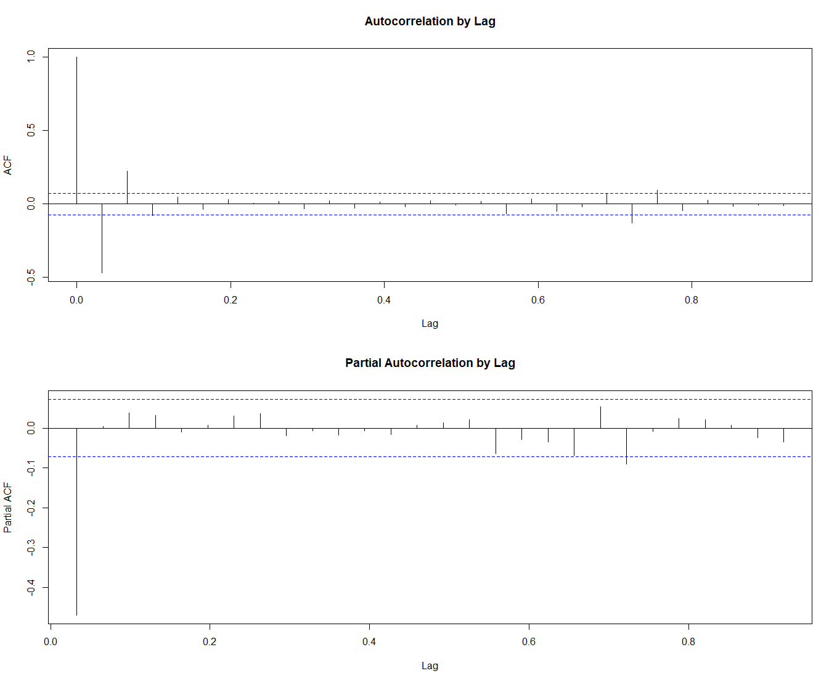
  - Spectral Density - (Elleh, 2024)
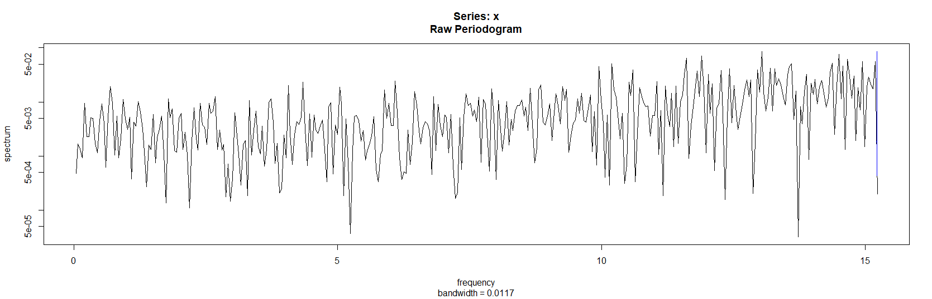
The chart above shows the spectral density of the time series data, and the plots below show the spectral density using the training data set.
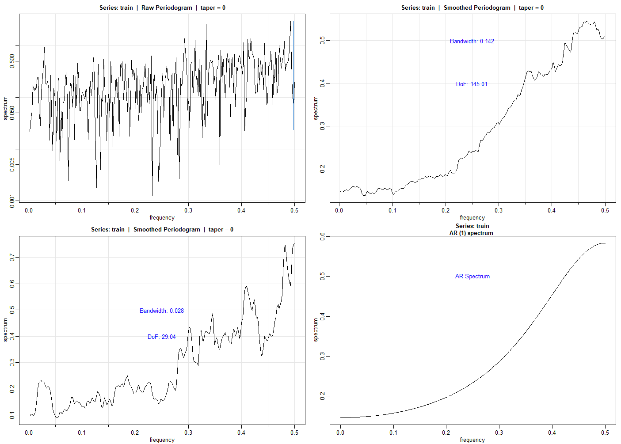
  - Decomposed Time Series - (Elleh, 2024)The plots below show the decomposed components of the time series. Highlighting the three components Seasonality Trends and Residuals

  - Confirmation of the lack of trends in the residuals of the decomposed series with a ADF test to confirm (Elleh, 2024)

ARIMA Model:

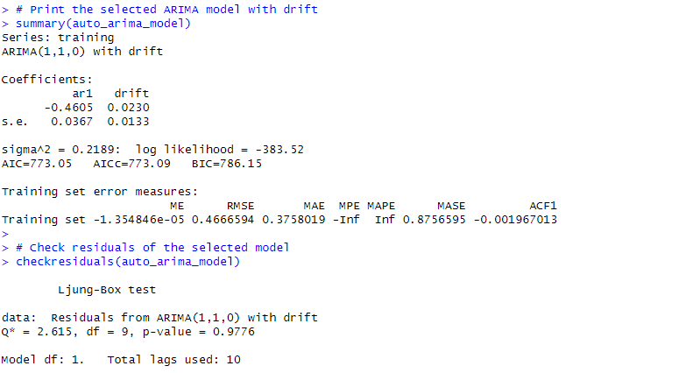

Forecast Using the Derived ARIMA Model:
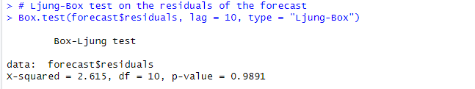
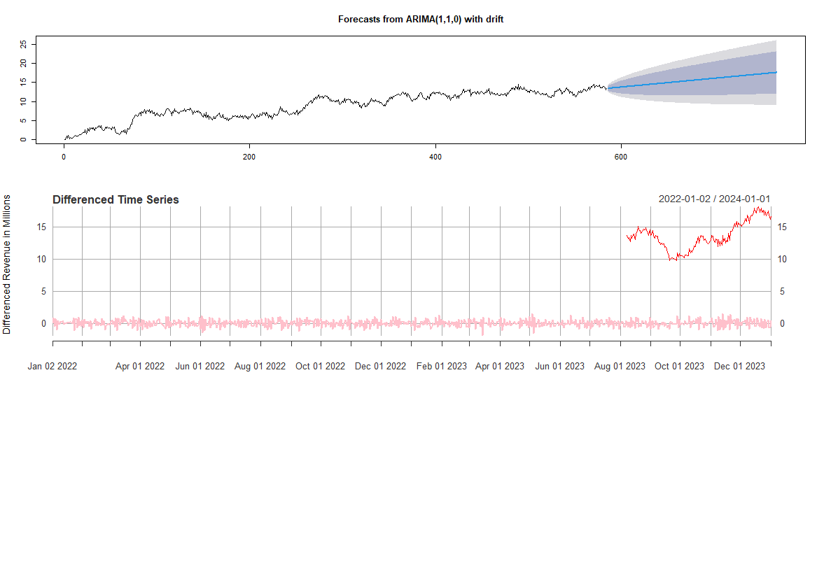

Output and Calculations:

Code Used: (Elleh, 2024), (R CODER , 2024)

Part V:Data Summary and Implications

Summarize of Findings

Results of the Data Analysis
- the selection of an ARIMA model
- the prediction interval of the forecast
- a justification of the forecast length
- the model evaluation procedure and error metric

Forecast Annotated Visualization Comparison

Recommended Course of Action

Part VI: Reporting

Panopto Video

Link:

R Markdown Document

References

